Christine Pries

“Inspection” of barnard.edu

Familiar:

* Always same overall structure <html> <head> <body>
* Linking to CSS stylesheets

Confusing:

* Many words for commands that I don’t know
* 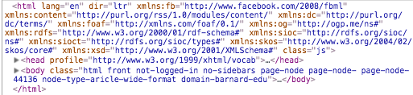
  + Facebook url? But link doesn’t lead to a Facebook page when I type it in?

Picking up new things:

* Was too confused to pick up anything new but I did learn it is possible to exactly copy someone’s website by just copy and pasting what you see when you click inspect!